Objective:

The objective is to install MySQL client or MySQL server on Ubuntu 18.04 Bionic Beaver Linux

Install MySQL on Ubuntu:

MySQL is an open-source database management system, commonly installed as part of the popular LAMP(Linux, Apache, MySQL, PHP/Python/Perl) stack. It uses a relational databases and SQL (Structured Query Language) to manage its data. The short version of the installation is simple: update your package index, install the mysql- server package, and them run the included security script.

On Ubuntu 18.04, only the latest version of MySQL is included in the APT package repository by default. At the time of writing, that’s MySQL 5.7

Log into MySQL :-

In order to use a password to connect toMySQL as root, you will need to switch its authentication method from sudo apt. To do this, open up the MySQL prompt from your terminal:

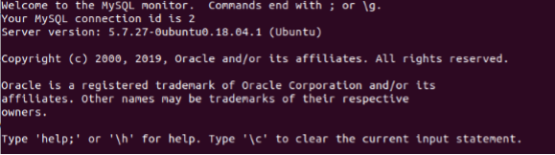

**Create database:-**

The CREATE DATABASE statement is used to create a new SQL database.

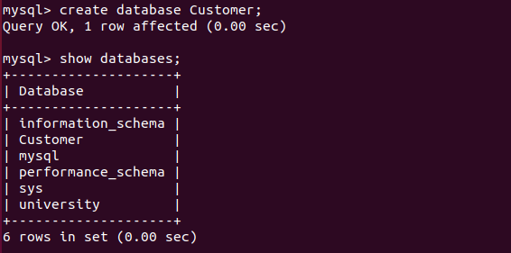

**Show tables:**

We have to select a database . Then we can make a table. After that we will able to insert data.

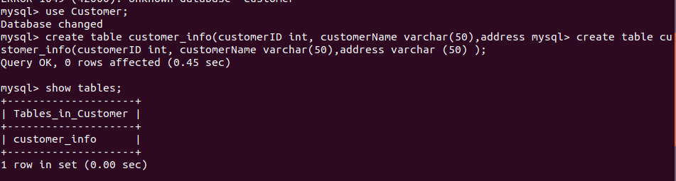

**Describe table:**

To show the table information , we use this command.

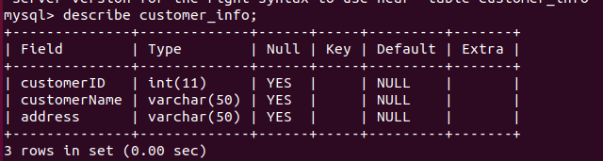

**Insert data:**

**To insert data “inserte data into ‘table name’ values(values);”**

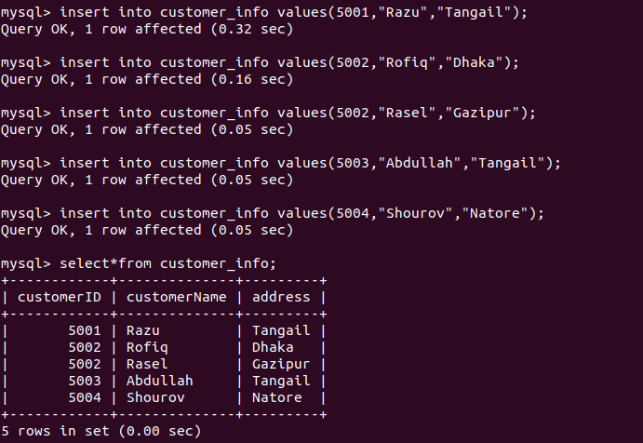

**Show information :**

**“**select *(all) from Table name;”

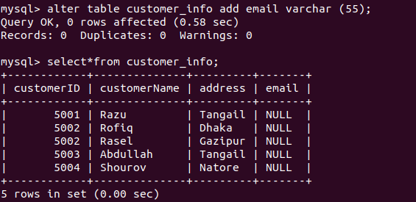

**Update table:**

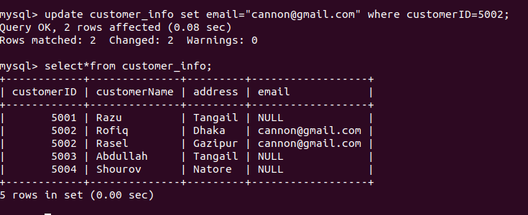

**Alter table:**

The ALTER TABLE statement is used to add, delete, or modify columns in an existing table

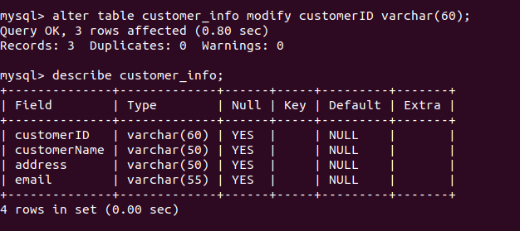

**Use of ‘where’ key word:**

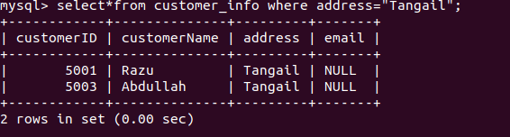

**Delete from table:**

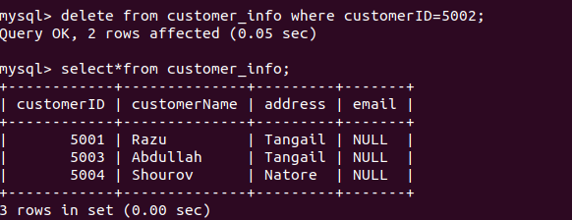

Drop data of table:

The DROP TABLE statement is used to drop an existing table in a database.



Conclusion : It is so heard to install mysql on Ubuntu. It is install successfully . we execute the statement show database , create table , delete table , insert data into table ,